**World Quant University**

**Professor: Ritabrata Bhattacharyya**

**Alpha Design II**

Nikolas Lippmann Pareschi - [nikolaslippmann@gmail.com](mailto:nikolaslippmann@gmail.com)

Introduction: Spyder PEP8 checker is truly a time saver, as I discovered reading the Piazza forum in Python 2. So, I have used it again for all classes and this Project I from Alpha Design II. I tried my best to avoid using modular code.

**Final Project: Seeking Alpha**

**Seeking Alpha**

* + - 1. Download/access End-of-day data for last 25 years for the entire set of constituents for the DOW Jones Industrial Average, namely the following:

3M (3M)

American Express (AXP)

Apple (AAPL)

Boeing (BA)

Caterpillar (CAT)

Chevron (CVX)

Cisco Systems (CSCO)

Coca-Cola (CCE)

Disney (DIS)

Dupont (DFT)

ExxonMobil (XOM)

General Electric (GE)

Goldman Sachs (GS)

Home Depot (HD)

IBM (IBM)

Intel (INTC)

Johnson & Johnson (JNJ)

JPMorgan Chase (JPM)

McDonalds (MCD)

Merck (MRK)

Microsoft (MSFT)

NIKE (NKE)

Pfizer (PFE)

Procter & Gamble (PG)

Travelers (TRV)

United Technologies (UTX)

UnitedHealth Group (UNH)

Verizon Communications (VZA)

Visa (V)

Wal Mart (WMT)

The first step of the final project was done in the beginning of the main function:

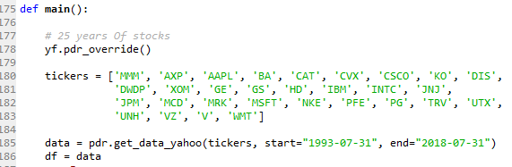

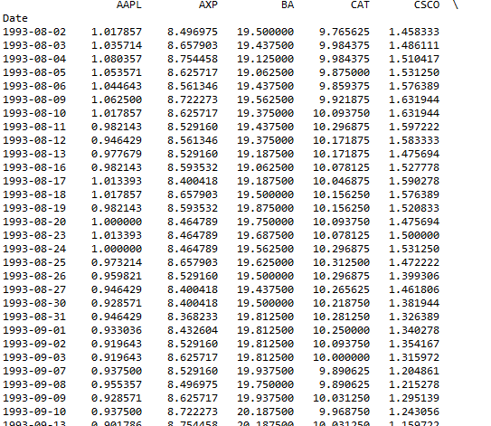

* + - 1. Constitute a trend trading system:

Use Exponential Moving of prices choosing period as:

21 Day

45 Day

Enter trades when prices move beyond 0.5 ATR(Average True Range) on either side of the moving average Close position when prices cross the moving average in the opposite direction.

First I made calculations to compute the ATR. Afterwards I coded the 2 Trade Systems considering the moving averages:

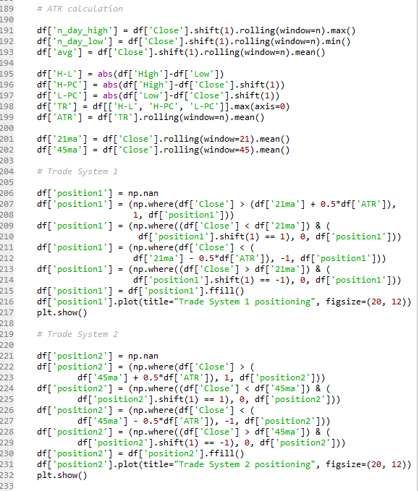

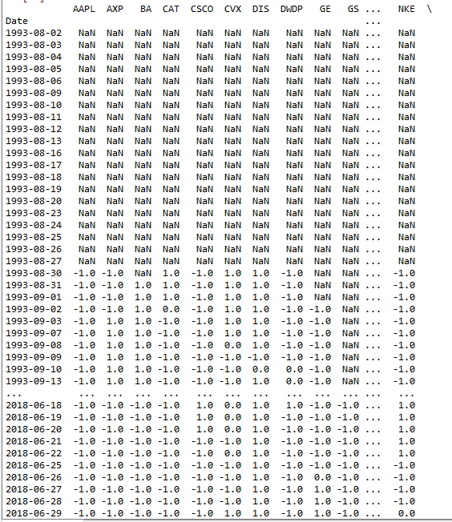

Run the system in each of the following three Position Sizing modes

Percent Volatility Model

Market’s Money Model

Multiple Tier Position Sizing

Now I coded each system, trade system 1 and 2 for each of these 3 position sizing modes. These pictures are from system 1:

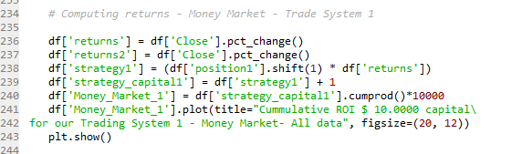

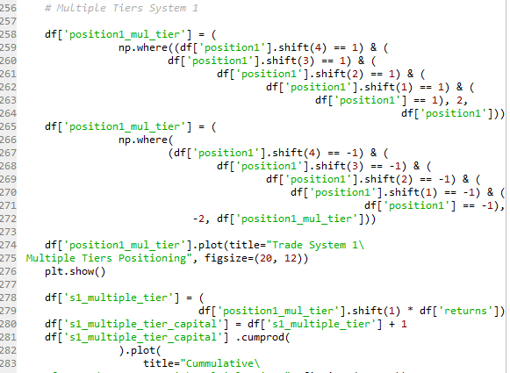

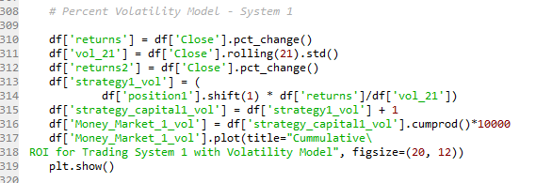

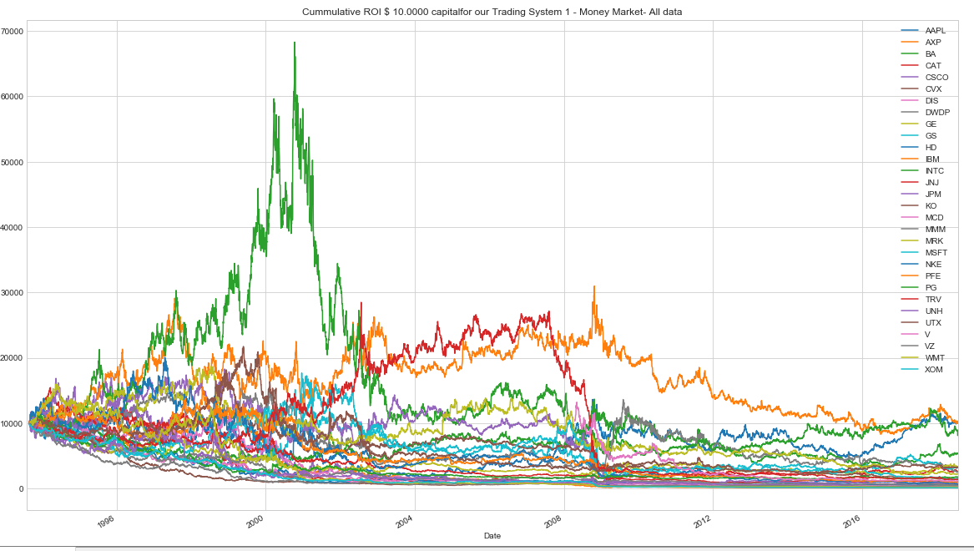

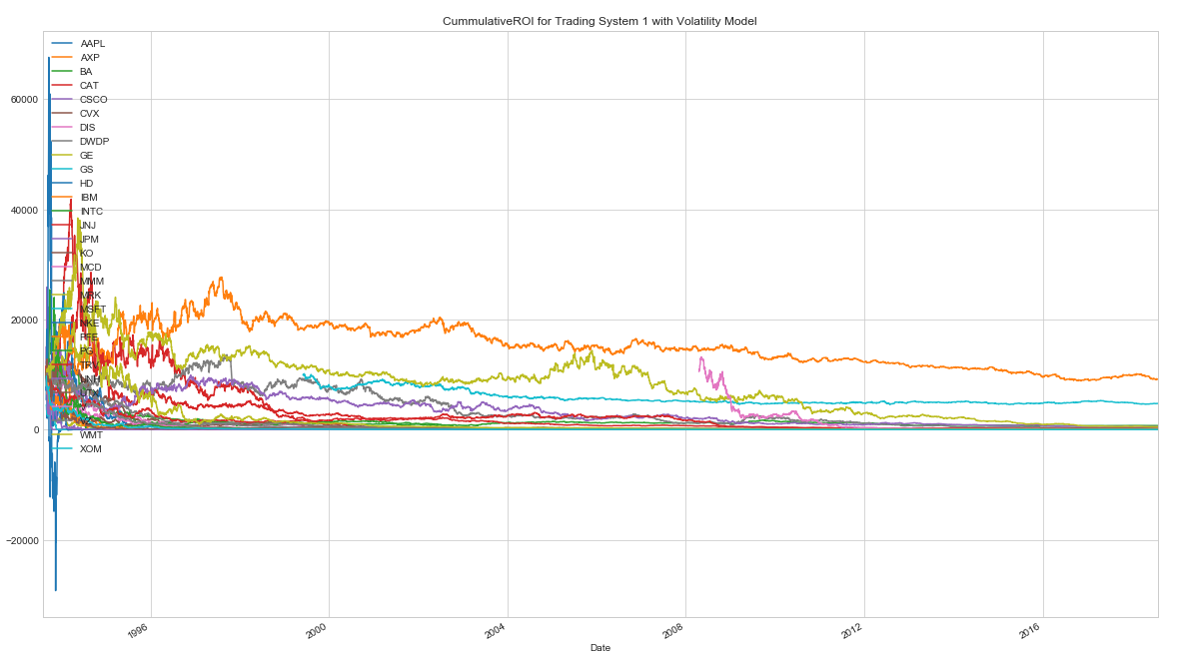

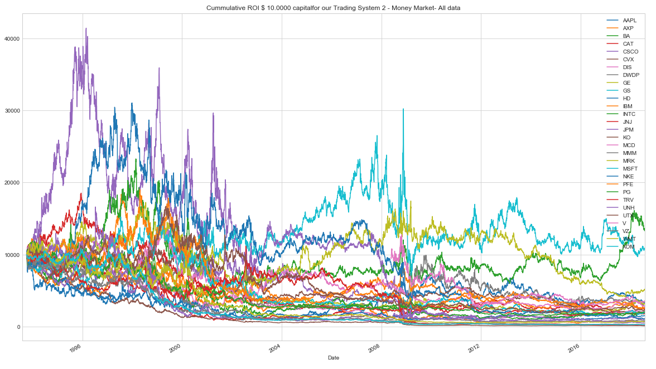

Design and implement the pyramiding strategies mentioned below to add on to your positions once the trade starts moving in a favorable direction

* Upright pyramid
* Inverted Pyramid
* Reflecting pyramid

Initial entry into trades would be based on the pyramiding strategy chosen (mentioned above), and then new positions would be added on top of it

I then coded the 3 pyramids, upright, inverted and reflected. Then I applied these 3 pyramids into the 2 systems with 3 positioning modes each. Total of 18 trade systems:

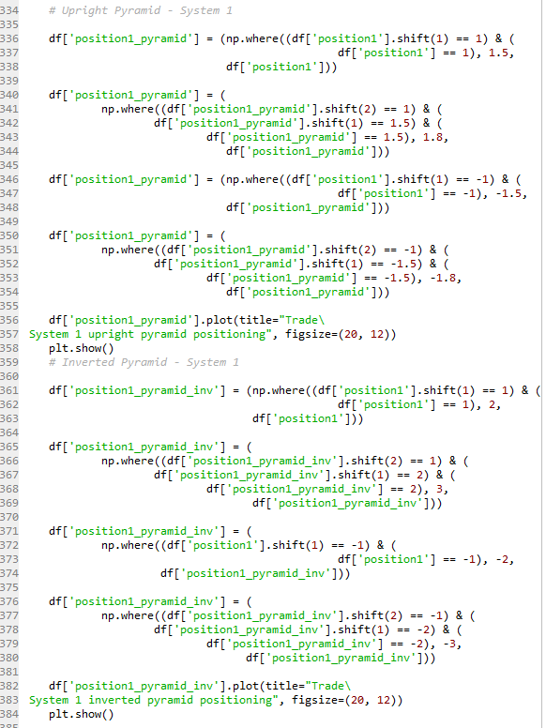 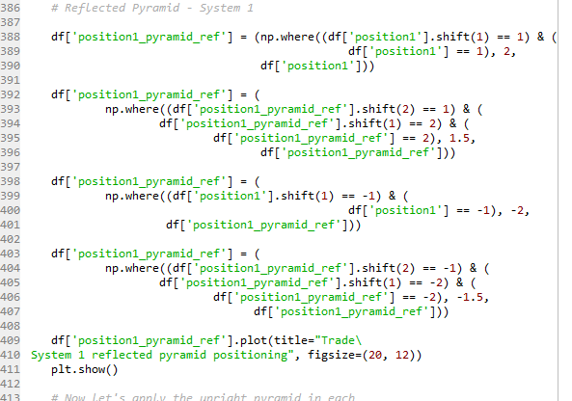

Consider realistic values for Slippage and Brokerage per trade

* + - 1. Clearly mention and explain all other trading rules and assumptions

The logic is simple, we apply the pyramid into each system 21 and 45 moving averages with the need of an ATR breakout considering the positioning (money market, volatility and multiple tiers.

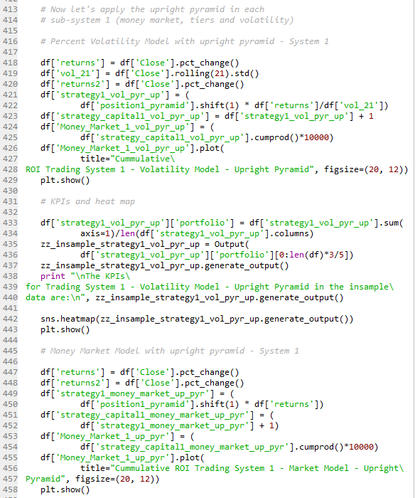

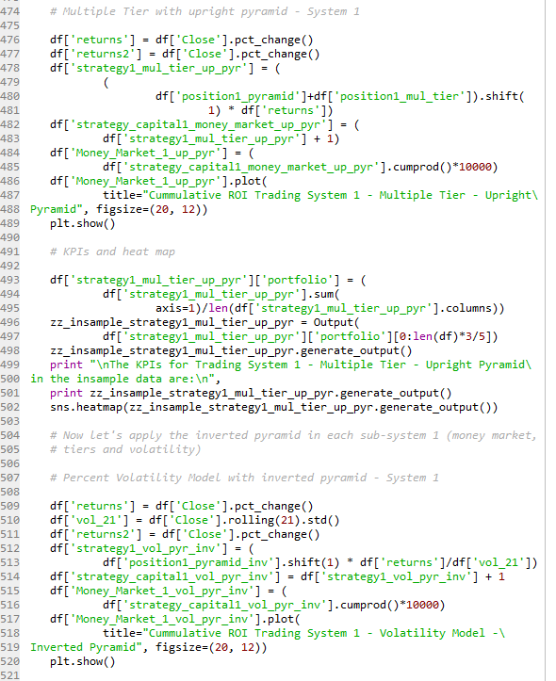

* + - 1. Backtest the performance of the systems (18 flavors of the same system – one for each MA Period-Pyramiding-Position Sizing combination) on the first 60% of the downloaded data for each of the 30 Stocks of the Dow Jones Industrial Average.

Each system was backtested considering 60% of the data. They provided the following KPIs:

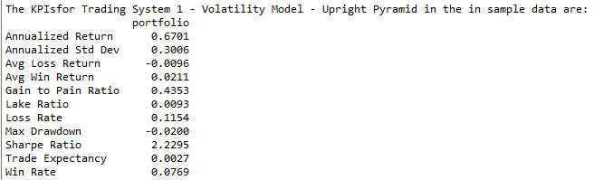

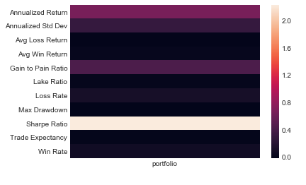

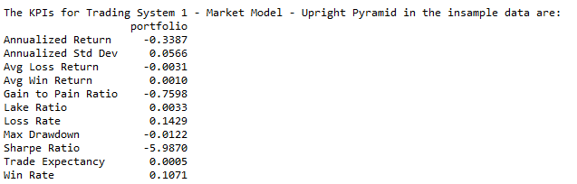 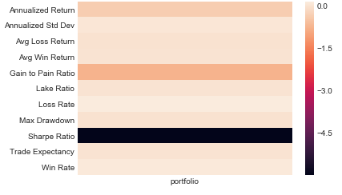

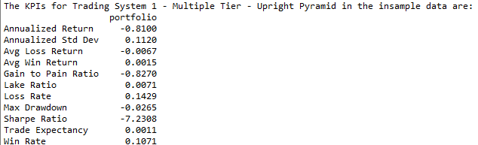 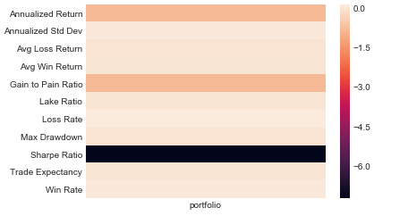 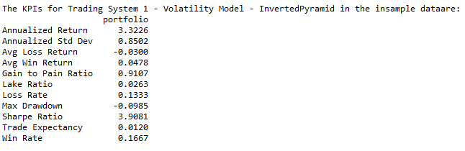 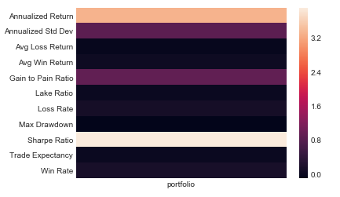

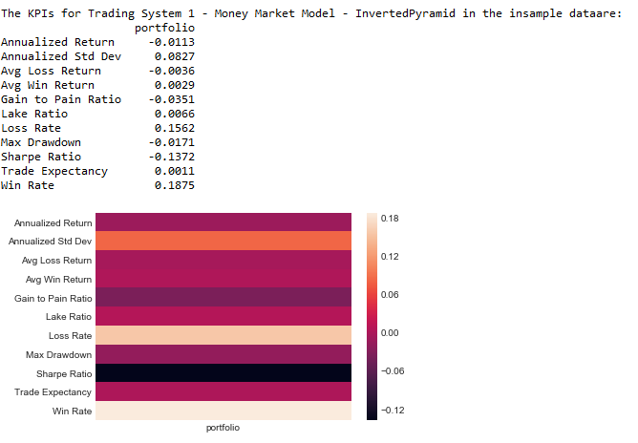

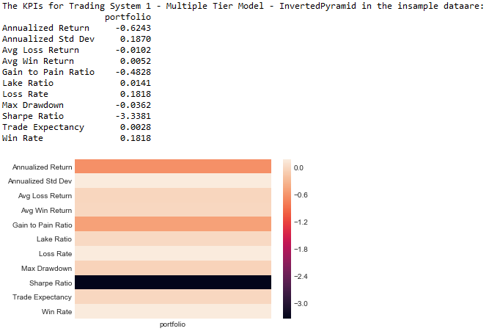 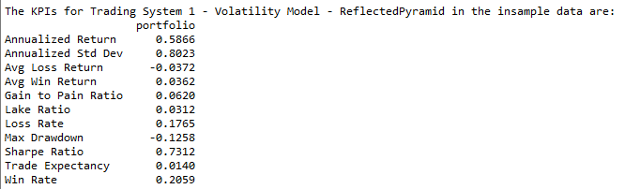 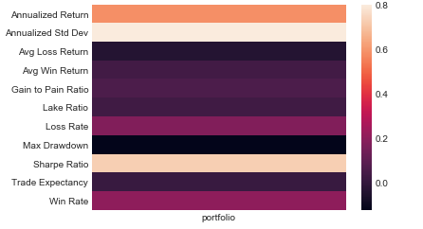 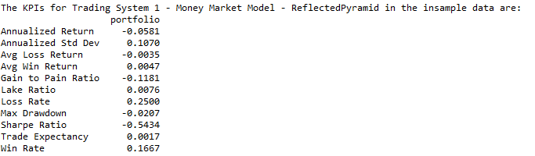 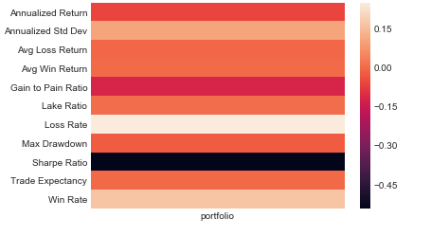 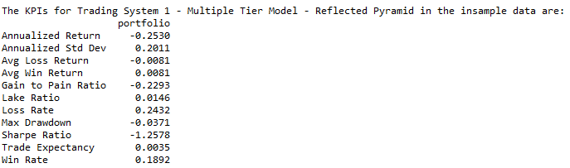 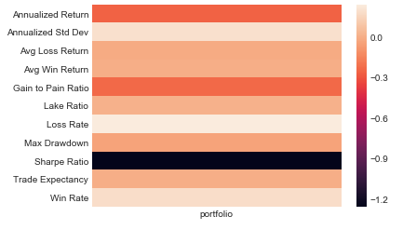

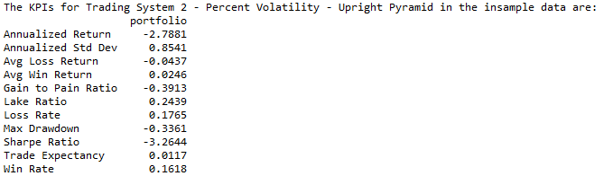 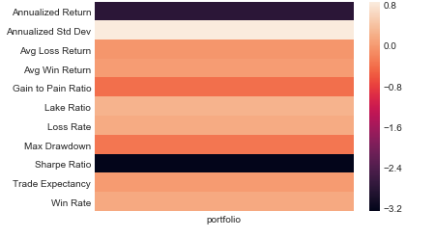 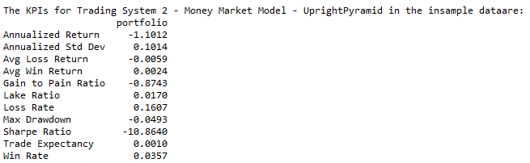 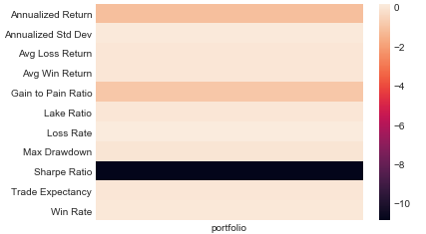

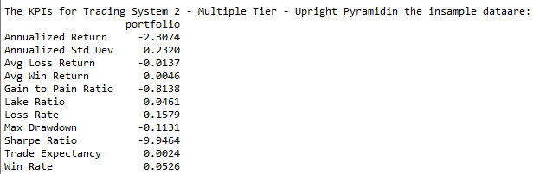

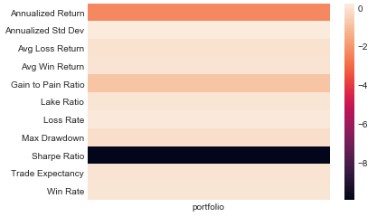

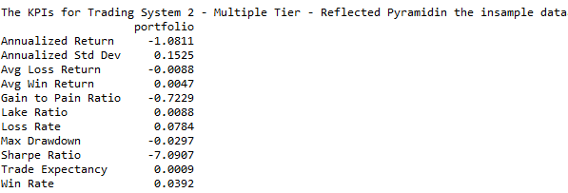

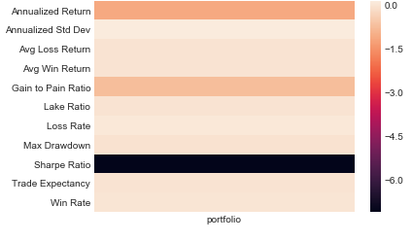 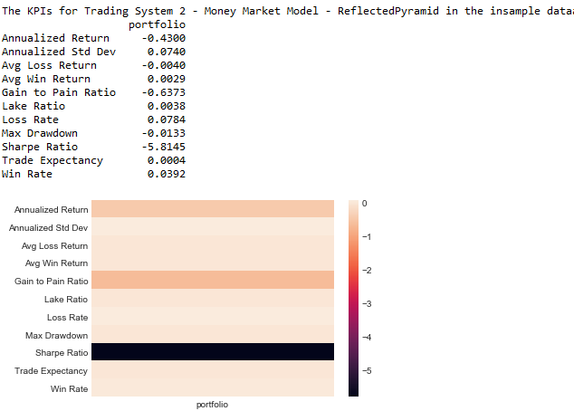

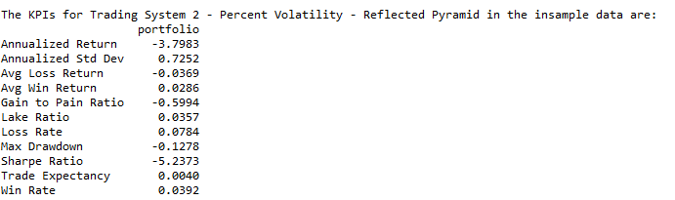

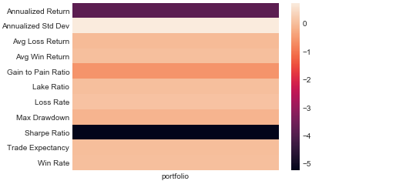

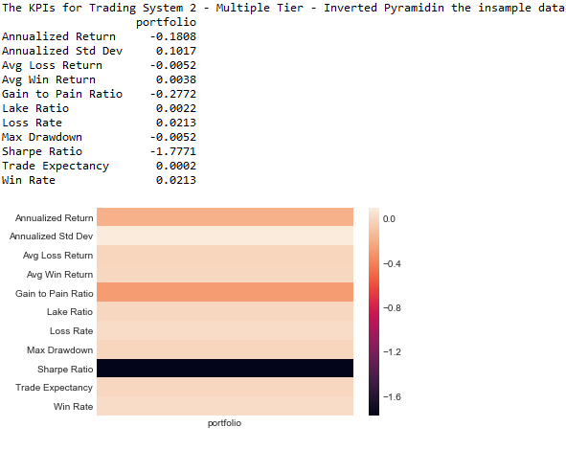

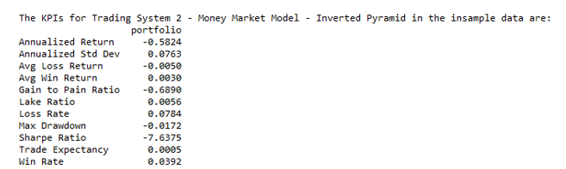 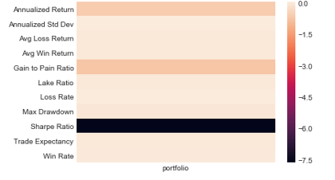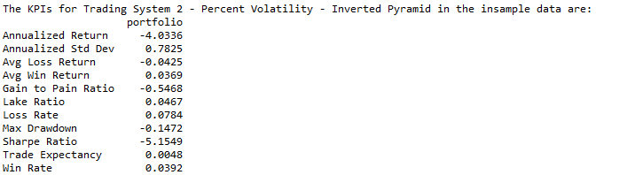 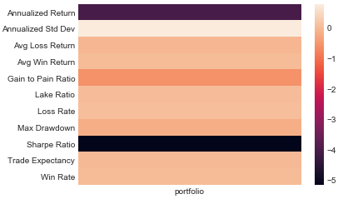

* + - 1. Plot a heat map/graphically represent in some other way the mean performance of the systems across the universe of stocks for each of the relevant KPIs

Win %

Win to Loss Ratio

Mean Return Per Trade

Maximum Consecutive Losers

Maximum Drawdown

CAGR

Lake Ratio

Gain to Pain Ratio

The heat maps we presented above together with the KPIs

* + - 1. Based on the comparative evaluation choose the most robust combination of MA Period-Pyramiding-Position Sizing options.

The best trading system in the in sample data was the percent volatility of system 1 (faster SMA) considering an inverted pyramid.

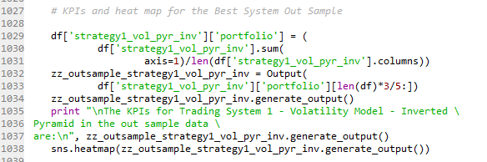

* + - 1. With this new combination rerun the backtest on out-of-sample data (the 20% remaining data) for all the stocks in the Dow Jones Industrial Average and calculate all the relevant KPIs as marked below

Win %

Win to Loss Ratio

Mean Return Per Trade

Maximum Consecutive Losers

Maximum Drawdown

CAGR

Lake Ratio

Gain to Pain Ratio

Unfortunately the results were not good in the out sample data:

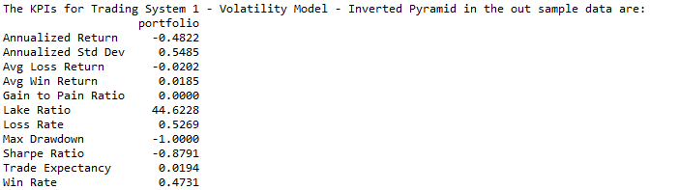

* + - 1. Analyzing  the returns characteristics of the chosen system on the set of 30 stocks, create a equal weighted portfolio of 10 stocks with the highest degree of non-correlation

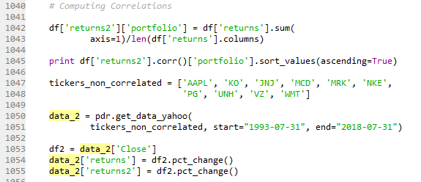

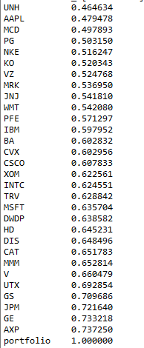

* + - 1. Calculate the performance of such an equal weighted portfolio for the entire duration of the data. Also calculate the performance of a simple-buy and hold strategy that invest in the Dow Jones Index itself (use the index prices as a proxy)
      2. Report and graphically represent the degree of outperformance observed and other comparative characteristics:

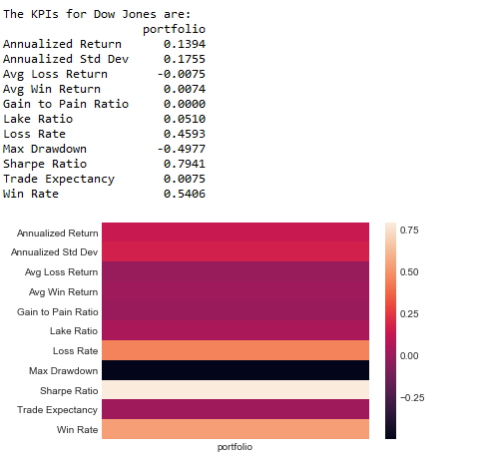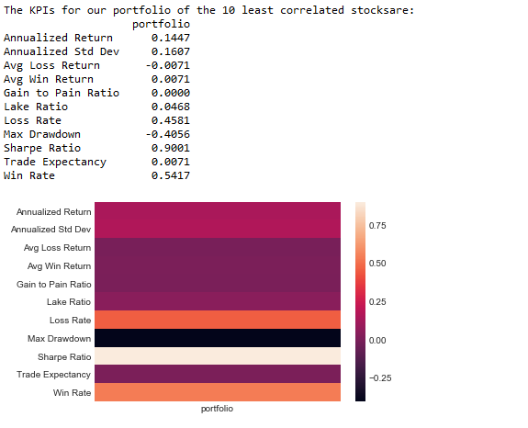

As we can notice the portfolio with the least correlated stocks presented superior returns.

* + - 1. Suggest ways to improving the Alpha generation characteristics of the system

In General the trade system presented poor results. I believe this is a consequence of the way the systems shorted stocks. Basically the short happened in inflection points, in moments when it was the best time to buy. The moving averages have some delay, so the system triggered a short usually in terrible moments. A basic way to improve the system is to not short stocks. Another way is to increase position (buying more) in these moments where the price crosses the moving average below 0.5 ATR.